Session 4 Online Diary – Skill and chance

Cory Arnett-O’Brien

ID: 20158721

# 3.0 Game premise

The game is based around the original noughts and crosses and features additional luck elements in the gameplay through a dice rolling system. This forces players to adjust their strategies based on the dice outcome and makes the game more dynamic when compared to the original noughts and crosses.

# 3.1 Materials

The game prototype was created using Construct 3. To create the presentation, google docs and Microsoft PowerPoint were used. Finally, Itch.io was used to distribute the game between players.

# 3.2 Rules

To decide who goes first players must roll a die, whichever player gets the highest roll gets to go first

During the first turn, the players do not roll the dice but instead place a shape each (as if they rolled a 1-2)

At the start of each subsequent turn, the players roll the die to decide on what action they can take during that turn.

* Rolling a 1 or 2 - Allows the player to place their respective shape (either a nought or a cross).
* Rolling a 3 - Remove one of your shapes.
* Rolling a 4 - Swap your shapes place with one of the other players.
* Rolling a 5 - Miss your turn.
* Rolling a 6 - Place a shape for the other player.

Players must always have at least one shape on the board at all times. During this time if they roll a 3, they skip their turn.

The winner is the player that forces their opponent to complete a line of 5 in any direction.

# 3.3 How to use the software

A

D

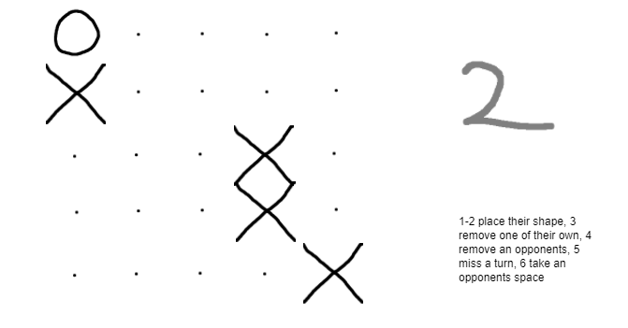The game is played locally between 2 players

C

Left-click for X, Right-click for O,  Middle click to clear a space, Click the number on the right to roll a dice.

E

B

# 3.4 Playtesting

Figure 1 (A-Nought, B-Empty squares, C-Cross, D-Dice, E-Brief Rules

During internal playtesting it was discovered that the game needed to be easier to understand and use, consequently a few quality of life features were added such as the ability to clear a space and also the implementation of the rules into the game window.

During external playtesting it was pointed out the game lasts too long and that it was challenging to learn. Following this test, the rules were reworded for better legibility

# 3.5 Teamwork

Delegation of tasks played a key role in creating this project, and it could not have been achieved without communication between team members in order to allocate tasks.

Communication between team members was also key when addressing the feedback from both internal and external testing.

# 3.6 Team members

**Developers -** Connor Winspur, Cory Arnett-O’Brien, Ngozi Egonu, Akash Sroay.

**External Play Testers** - Jessica Evans, Hou Yap, Joshua Baker, Zakaria Ahmed.